https://lh6.googleusercontent.com/ZbSIWMo4cow4QNJGA6BveANighDY2_y1CMANa5citrT0ZKaBLxYbxfT-zNV4nV6jZSe7GbYkxIvsv2UQbzEC92oVcW-jMaPgbCVKsddyyd-NH5iW-5ids8pNvEGYhTEQ97jAA1bN

**Computer Science and Engineering**

_______________________________________

**Taskr**

**System Project Management Plan**

**Version 1.1**

Document Number: SPMP-001

Project Team Number: B12

Project Team Members: Franky Cen Kenan Millet Yatin Kaushal

fc948 kvm237 yk1279

**REVIEW AND APPROVALS**

|  |  |  |  |
| --- | --- | --- | --- |
| **Printed Name and Title** | **Function (Author, Reviewer, Approval)** | **Date** | **Signature** |
| Franky Cen | Author | 4/2/2016 | Franky Cen |
| Kenan Millet | Author | 4/3/2016 | Kenan Millet |
| Yatin Kaushal | Author | 4/4/2016 | Yatin Kaushal |
| Franky Cen | Reviewer | 4/6/2016 | Franky Cen |
| Kenan Millet | Reviewer | 4/6/2016 | Kenan Millet |
| Franky Cen | Approver | 4/6/2016 | Franky Cen |
| Franky Cen | Author | 9/24/2016 | Franky Cen |
| Franky Cen | Reviewer | 9/25/2016 | Franky Cen |
| Yatin Kaushal | Reviewer | 9/27/2016 | Yatin Kaushal |
| Kenan Millet | Author | 9/27/2016 | Kenan Millet |
| Kenan Millet | Reviewer | 9/27/2016 | Kenan Millet |
| Franky Cen | Approver | 9/27/2016 | Franky Cen |

**REVISION LEVEL**

|  |  |  |
| --- | --- | --- |
| **Date** | **Revision Number** | **Purpose** |
| 4/2/2016 | Version 1.0 | Initial creation of the document |
| 9/24/2016 | Version 1.1 | Completion of the document |

**TABLE OF CONTENTS**

**1.   Overview ……………………….……………………………………………………….5**

1.1   Project Summary ……………………………………………………………………….5

1.2   Purpose, Scope, and Objectives ……………………………………………………….5

1.3   Assumptions and Constraints ………………………………………………………….5

1.4   Project Deliverables ………………………………………………………………….6

1.5   Schedule and Budget Summary ……………………………………………………….6

1.6   Evolution of the Plan ………………………………………………………………….6

**2.   References ……………………………………………………………………………...7**

**3.   Definitions ……………………………………………………………………………...7**

**4.   Project Organization ………………………………………………………………...7**

4.1   External Interfaces …………………………………………………………………….7

4.2   Internal Structure ……………………………………………………………………...7

4.3   Roles and Responsibilities …………………………………………………………...8

**5.   Management Processes …………………………………………………………….8**

5.1   Start-Up Plan ………………………………………………………………………...8

5.1.1   Estimation Plan …………………………………………………………………….8

5.1.2   Staffing Plan ……………………………………………………………………….8

5.1.3   Resource Acquisition Plan ………………………………………………………...8

5.1.4   Training Plan ……………………………………………………………………….8

5.2   Work Plan ……………………………………………………………………………...9

5.2.1   Work Activities …………………………………………………………………….9

5.2.2   Schedule Allocation ………………………………………………………………...9

5.2.3   Resource Allocation ………………………………………………………………...9

5.2.4   Budget Allocation ………………………………………………………………….9

5.3   Control Plan …………………………………………………………………………….9

5.3.1   Requirement Control and Traceability ………………………………………………9

5.3.2   Schedule Tracking and Adjustment …………………………………………………9

5.3.3   Budget Tracking and Adjustment ……………………………………………………10

5.3.4   Quality Control …………………………………………………………………...10

5.3.5   Reporting Mechanisms …………………………………………………………...10

5.3.6   Metrics Collection Plan ………………………………………………………….10

5.4   Risk Management Plan ……………………………………………………………….11

5.5   Post Implementation Plan …………………………………………………………...11

**6.   Technical Processes ……………………………………………………………….11**

6.1   Process Model ……………………………………………………………………….11

6.2   Methods, Tools, and Techniques ……………………………………………………….11

6.3   Infrastructure Plan …………………………………………………………………….11

6.4   Produce Acceptance and Migration Plan ……………………………………………12

**7.   Supporting Processes Plans ………………………………………………………12**

7.1   Configuration Management Plan ………………………………………………………12

7.2   Qualification (Verification and Validation) Plan ………………………………………12

7.3   Documentation (Library) Plan ……………………………………………………….12

7.4   Quality Assurance Plan ……………………………………………………………….13

7.5   Reviews and Audits …………………………………………………………………...13

7.6   Problem Resolution Plans …………………………………………………………...13

7.7   Environment Management Plans ……………………………………………………13

7.8   Process Improvement Plan ………………………………………………………….14

**8.   Additional Plans …………………………………………………………………….14**

**9.   Rationale …………………………………………………………………………….14**

**10.   Appendix …………………………………………………………………………...15**

10.1   Schedule Tracking ………………………………………………………………….15

10.2   Defect Tracking ……………………………………………………………………...16

10.5.1.2 Staffing Plan ….……………………………………………………………………17

10.5.2.1 WBS ………………………………………………………………………………18

10.5.2.2   Schedule Allocation Table (Gantt Chart) …………………………………………19

10.5.2.3 Resource Allocation Table ………………………………………………………20

10.6.1 Process Model …………………………………………………………………….21

10.7.3 Documentation (Library) Plan …………………………………………………....22

10.7.5 Reviews and Audits Plan ……………………………………….……………23-24

**1.   Overview**

**1.1** **Project Summary**

The purpose of the Software Project Management Plan (SPMP) is to provide a plan that details the tools, methods, life cycle model, management process, and deadlines that will be used during the life cycle of this project. The intended audience for this document is the client, the development team, the software quality group, and the advisor to the development team, Fred Strauss.

**1.2   Purpose, Scope, and Objectives**

The objectives of the project are to complete the project on time, within budget, and to create a product that meets the user’s needs. This project will provide all deliverables by the expected due date. Each deliverable must be correct, complete, and concise.

This product is expected to help users organize their schedules. Users will interact with the product, which can help create a schedule that most benefits the user. The information for the tasks and schedules are saved both locally and externally, on a server. This product will not force users to follow their schedule, or penalize them for doing so. However, if users do not follow their schedule, this product will adjust its suggestions accordingly. This product can be for personal, commercial, or business use.

From a business perspective, this product must be flexible, reliable, usable, and cost-efficient. This product should increase efficiency and save money for businesses.

**1.3   Assumptions and Constraints**

The project will have the following assumptions:

- The initial estimates for this project will greatly differ from the actual parameters

- The estimates and plans in this document are very likely to change

- This project will not go over budget

- This project will be completed on time

The project will be constrained by the following:

- The project is to be completed within by 12/23/2016

- The staff will consist only of the individuals in the development team

**1.4   Project Deliverables**

The deliverables will be delivered as single deliverables on the following dates:

The initial Software Requirements Specifications document was delivered on 03/07/16.

The final Software Requirements Specifications document was delivered on 03/23/16.

The initial Software Project Management Plan was delivered on 04/6/16.

The Software Analysis Specifications document was delivered on 04/11/16.

The Software Design document was delivered 04/25/16.

The final Software Project Management Plan will be delivered on 09/27/2016.

The Requirements and Analysis Specifications will be delivered on 10/04/2016.

The Software Design Description will be delivered on 10/25/2016.

The Design Document will be delivered on 11/25/2016.

**1.5   Schedule and Budget Summary**

Along with the delivery dates listed in Section 1.4 above,

the following items are scheduled to be delivered:

The product should be ready for operation by 12/23/2016.

**1.6   Evolution of the Plan**

All details listed in this document are subject to change. Small changes will lead to a revision of this document. Larger changes will be discussed by the team members before being applied to the document. Larger changes will only be applied after the team has agreed to make the change. Larger changes can include scheduling and budget modifications, as well as changes to any plan detailed later in this document.

All changes will be recorded in the changelog. The changelog will include an accurate and complete trail of changes. Requested changes will be recorded in the changelog. Changes will be implemented only after review and approval. The requester, reviewer, and approver of the change will also be recorded in the changelog.

**2.   References**

Taskr Project Proposal v1.0

Objectives

Rationale

Taskr Software Requirements Specification v1.1

Business Drivers / Documents

Context Diagram

Requirements Traceability

System Scope: Bounds, Objectives, and Overview

System Capability Requirements

Use Cases: Diagram and Descriptions

Other Various Requirements

**3.   Definitions**

SAS Software Analysis Specification

SDD Software Design Document

SPMP Software Project Management Plan

SRS Software Requirements Specification

SQA Software Quality Assurance

RAS Requirements and Analysis Specifications

WBS Work Breakdown Structure

**4.   Project Organization**

**4.1   External Interfaces**

This project team interacts with the project manager, the SQA group, the client, and the project advisor.

**4.2   Internal Structure**

The project team will be organized as a Democratic Team. There is no assigned leader. Each member of the team will have access to all resources. All documents will be shared amongst the team, as well as with the advisor. The project team will have one advisor that does not contribute to the creation of any deliverable.

**4.3   Roles and Responsibilities**

The development team is responsible for creating all deliverables.

All members of the development team are authors and reviewers for each deliverable.

The software quality team is responsible for assuring that the product and all deliverables are correct.

The advisor is responsible for making sure each deliverable meets all requirements and standards.

The SQA group is responsible for making sure the product works correctly.

Programmers work with developers to create the product.

A training specialist will train other members in the required skills needed.

**5.   Management Processes**

**5.1   Start-Up Plan**

**5.1.1   Estimation Plan**

The project is expected to be finished by 12/23/2016.

All estimations will be done and recorded by each project team member. These estimations will then be reviewed and finalized. These estimations include amount of time worked and number of faults for each deliverable. These are recorded in Appendix 10.1 and 10.2.

**5.1.2   Staffing Plan**

See Appendix 5.1.2

**5.1.3   Resources Acquisition Plan**

For documentation, the resources required are a platform to create deliverables, such as Microsoft Word. This platform is provided by the project team members. For implementation, the resources required are: an SQL server, and an Android smartphone for testing. An SQL server is provided by NYU Tandon School of Engineering. Android smartphones will be provided by the project team members.

**5.1.4   Training Plan**

Developers need to understand how to create and manage databases in SQL as well as how to communicate with the database on the mobile client side. Training in Android/iOS development necessary to implement the client-side application. All members of the development team will be trained.

**5.2   Work Plan**

**5.2.1   Work Activities**

See Appendix 10.5.2.1

**5.2.2   Schedule Allocation**

See Appendix 10.5.2.2

**5.2.3   Resource Allocation**

See Appendix 10.5.2.3

**5.2.4   Budget Allocation**

The budget plan will only include hours of work. Participants are not paid for this project. For this project, the only resource spent is time, which is shown in the Resource Allocation Table in Appendix 10.5.2.3.

**5.3   Control Plan**

**5.3.1   Requirement Control and Traceability**

A traceability matrix will be used to ensure requirement traceability. The traceability matrix is a document in the form of a table that can be used to check whether or not the current requirements are being met. New requirements will be added to the traceability matrix. The relationships of each succeeding artifact to their source document will be recorded so that there is both forward and backward traceability. When a requirement is changed in a source document, changes that need to be done in documents can be determined using the traceability matrix. Changes will be requested, reviewed, then approved before being applied.

**5.3.2   Schedule Tracking and Adjustment**

A Schedule Tracking Table is used for each deliverable. Each project team member inputs an estimated amount of work to be done. A timesheet is used to track the actual amount of work done. The final amount of work done is recorded on the tracking table. The Schedule Tracking Table is located in Appendix 10.1.

**5.3.3   Budget Tracking and Adjustment**

As stated in 5.2.4, the budget will refer only to hours of work. The amount of time worked is tracked using timesheets, and recorded in the Scheduling Tracking Table in Appendix 10.1. Both the estimated and actual number of working hours are recorded in that table. When the actual amount does not conform to the estimated amount, the difference is recorded. There is no corrective action when a deliverable takes more than the estimated amount of time. For each deliverable, the estimated and actual working hours (as well as their difference) are recorded.

**5.3.4   Quality Control**

The software quality team will develop the test plan with a set of test scenarios based on the Use Cases of the SRS. They will execute the tests and report any defects. Each feature of the product will be tested against several scenarios. This testing will ensure that the product functions correctly. The testing will be conducted using an SQL server. Each deliverable will be reviewed by the software quality team to ensure it is correct. If necessary, audits can be requested. Audits will be reviewed before being approved and applied.

**5.3.5   Reporting Mechanisms**

The project team members communicate with each other online using messengers and shared folders. The project team members communicate with the project advisor using email, a forum, and face-to-face. Project team members communicate with each other and the project advisor at least once a week throughout the project. Each deliverable is shared with all team members as well as the project advisor. Each deliverable is posted in an online portfolio. The team members, project advisor, and customer has access to this portfolio. This portfolio is updated during the middle and end of the project.

**5.3.6   Metrics Collection Plan**

Scheduling and defects are tracked for each deliverable.

See Appendix 10.1 and 10.2 for the Scheduling and Defect tracking tables.

Scheduling is recorded in work hours per person. Each team member will use a timesheet to record the amount of work effort put into each deliverable.

Defects are tracked during reviews. Each team member records the number of defects found for each deliverable.

**5.4   Risk Management Plan**

The approach we have taken to manage risks for this project included a methodical process by which the project team identified, scored, and ranked the various risks. The highest impact risks are added to the project schedule to ensure that the necessary steps needed to implement the mitigation response are taken. The project team will provide status updates on their assigned risks in the bi-weekly project team meetings, but only when the meetings include their risk’s planned timeframe. Upon the completion of the project, during the closing process, the project team will analyze each risk as well as the risk management process. Based on this analysis, the project team will identify any improvements that can be made to the risk management process for future projects.

**5.5   Post Implementation Plan**

When the project ends, all deliverables and related documents will have been saved in the project portfolio. One copy of the documents will be archived in a shared folder that the project team members have access to. Personal copies of all data will be saved in separate locations. All project team members will meet online to prepare for a Post Implementation Review. As stated in 5.4, risks will be analyzed during the closing process.

**6.   Technical Processes**

**6.1   Process Model**

See Appendix 10.6.1

**6.2   Methods, Tools, and Techniques**

Development methodologies and programming languages will be determined at a later date. Microsoft Word, along with Google Docs will be used to maintain project deliverables. The SRS details how each deliverable will be maintained.

**6.3   Infrastructure Plan**

The team will have three laptops at their disposal for mobile app client-side development and an online SQL database to store everything on. Additionally, all the resources the university has to offer (such as printers, copiers, computers, and books) will be used by the team throughout the process.

**6.4   Product Acceptance and Migration Plan**

The product is reviewed and tested by each project team member. The product will also be checked for correctness. Several test cases will be run to see if the product functions correctly. The product must pass all test cases before it is submitted. Once the product is deemed acceptable by the team members, it will be submitted to the project advisor for approval. If there are any problems, they will be addressed and corrected before finalization.

**7.   Supporting Processes Plans**

**7.1   Configuration Management Plan**

Configurations will be identified, named, and documented. Configuration changes will be requested, reviewed, then approved. Changes will only occur if they are approved. These changes will be documented in the changelog.

In order to make a configuration into the baseline, the development team will meet to evaluate the configuration. Once there is a mutual agreement, the configuration is baselined. All members of the team are notified of the creation of this baseline.

**7.2   Qualification (Verification and Validation) Plan**

The verification and validation process will be performed on the product requirements, design, and interface. This process will mainly involve reviews, inspections, and evaluations. This process will be conducted by the software quality team. Each item during this process will be traced to its source. Requirements can be traced by using the traceability matrix. The design and interface can be traced by using the Software Design Document. For each item that is verified and validated, a report will be written that includes discovered problems and proposed solutions. This report is used to evaluate that item.

**7.3   Documentation (Library) Plan**

See Appendix 10.7.3

**7.4   Quality Assurance Plan**

Quality assurance procedures will be used to ensure that all deliverables will adhere to the documentation standards and plans/designs stated in this document. These procedures include analysis, inspections, reviews, audits, and assessments. Quality assurance will be conducted by the software quality group. Quality reviews will be also conducted once the product is complete. These reviews will take place once a week while production is active.

**7.5   Reviews and Audits**

See Appendix 10.7.5

**7.6   Problem Resolution Plan**

All problems will be documented, analyzed, processed, and resolved. The analyzation will determine the severity of the problem, the risk that it poses to the system, and the impact it will have on resources, schedule, and budget. More severe problems will be given priority for processing and resolution.

Once a problem has been analyzed, a report will be generated that includes the problem name, a brief description, severity, priority, risks, and impacts. The problem will be processed and resolved after this report is made.

**7.7   Environment Management Plan**

The development and testing environments will be managed by the project team members. Each team member will have a separate personal environment. Programming tools will be used to develop and test the product. Programmers and developers will have access to all product environments. These environments will be checked to make sure they comply with each other, and that they are adequate for the product. These environments will be maintained by the project team members.

**7.8   Process Improvement Plan**

The project will be checked periodically while it is in progress. Project team members will check for areas of improvement while checking for errors. Each project item will be reviewed first. During this review, areas will be marked for possible improvement and possible errors. While resolving errors, the source of the error will be examined for possible improvements. When making improvements, the changes will be reviewed so that they do not interfere with any other product item. If the changes are important, then all project team members will be consulted with before changes are made. The amount of changes will be determined and recorded.

**8.   Additional Plans**

No additional plans.

**9.   Rationale**

Time management is a problem that many in first world countries face. We believe that the solution to efficient use of time is through the proper mindset. Unfortunately, due to entertainment, stress, friends, family, and many other important but deviating tasks, such a mindset can be very difficult to adopt and equally difficult to maintain. In order to help the population adapt to the mindset of the successful, we will develop an application that acts as a scheduler that can be used to help ease people into managing their time efficiently.

**10.   Appendices**

**10.1   Schedule Tracking**

|  |  |  |  |  |
| --- | --- | --- | --- | --- |
| SRS - Initial | Franky  Kenan  Yatin | 14 hours  12 hours  15 hours | 8 hours  14 hours  7 hours | 6 hours  2 hours  8 hours |
| **Total** | **41 hours** | **29 hours** | **12 hours** |
| SRS - Final | Franky  Kenan  Yatin | 15 hours  20 hours  15 hours | 9 hours  6.5 hours  5 hours | 6 hours  12.5 hours  10 hours |
| **Total** | **50 hours** | **20.5 hours** | **29.5 hours** |
| SPMP - Initial | Franky  Kenan  Yatin | 13 hours  18 hours  10 hours | 16.5 hours  12 hours  7 hours | 3.5 hours  6 hours  3 hours |
| **Total** | **41 hours** | **35.5 hours** | **5.5 hours** |
| SAS | Franky  Kenan  Yatin | 15 hours  12 hours  15 hours | 13 hours  7.5 hours  8 hours | 2 hours  4.5 hours  7 hours |
| **Total** | **42 hours** | **28.5 hours** | **13.5 hours** |
| SPMP - Final | Franky  Kenan  Yatin | 8 hours  3 hours  2 hours | 4 hours  2 hours  1 hours | 4 hours  1 hour  1 hour |
| **Total** | **13 hours** | **7 hours** | **6 hours** |

**Cumulative**

|  |  |  |  |
| --- | --- | --- | --- |
| **Individual** | **Estimated** | **Actual** | **Difference** |
| Franky  Kenan  Yatin | 65 hours  65 hours  57 hours | 50.5 hours  42 hours  28 hours | 14.5 hours  23 hours  29 hours |
| **Total** | **187 hours** | **120.5 hours** | **66.5 hours** |

**10.2   Defect Tracking**

|  |  |  |  |  |
| --- | --- | --- | --- | --- |
| **Artifact / Deliverable** | **Individual** | **Estimated** | **Actual** | **Difference** |
| SRS - Initial | Franky  Kenan  Yatin | 20 faults  10 faults  10 faults | 10 faults  6 faults  3 faults | 10 faults  4 faults  7 faults |
| **Total** | **40 faults** | **19 faults** | **21 faults** |
| SRS - Final | Franky  Kenan  Yatin | 20 faults  20 faults  15 faults | 24 faults  2 faults  3 faults | 4 faults  18 faults  12 faults |
| **Total** | **55 faults** | **29 faults** | **26 faults** |
| SPMP - Initial | Franky  Kenan  Yatin | 20 faults  20 faults  20 faults | 16 faults  17 faults  4 faults | 4 faults  3 faults  16 faults |
| **Total** | **60 faults** | **37 faults** | **23 faults** |
| SAS | Franky  Kenan  Yatin | 15 faults  20 faults  18 faults | 13 faults  12 faults  15 faults | 2 faults  8 faults  3 faults |
| **Total** | **53 faults** | **40 faults** | **13 faults** |
| SPMP - Final | Franky  Kenan  Yatin | 15 faults  10 faults  10 faults | 10 faults  4 faults  3 faults | 5 faults  6 faults  7 faults |
| **Total** | **35 faults** | **17 faults** | **18 faults** |

**Cumulative**

|  |  |  |  |
| --- | --- | --- | --- |
| **Individual** | **Estimated** | **Actual** | **Difference** |
| Franky  Kenan  Yatin | 90 faults  80 faults  73 faults | 73 faults  41 faults  28 faults | 17 faults  39 faults  45 faults |
| **Total** | **243 faults** | **142 faults** | **101 faults** |

**10.5.1.2 Staffing Plan**

|  |  |  |  |  |
| --- | --- | --- | --- | --- |
| **Human Resource Type** | **Project Phases** | **Qty.** | **Source** | **Work (hours)** |
| Project Manager | All | 1 | Existing | 500 |
| Requirements Analyst | Requirements | 2 | Existing | 100 |
| Programmer | Implementation | 3 | Existing | 150 |
| Verification Engineer | Requirements  Implementation  Design | 2 | Existing | 250 |
| Software Designer | Design | 1 | Existing | 100 |
| Database Engineer | Implementation  Installation | 2 | Existing | 130 |
| Quality Analyst | All | 3 | Existing | 300 |
| Technical Writer | Documentation | 3 | Existing | 240 |
| Training Specialist | Training | 1 | Existing | 60 |
| Installation Specialist | Installation | 2 | Existing | 50 |

**10.5.2.1   WBS**

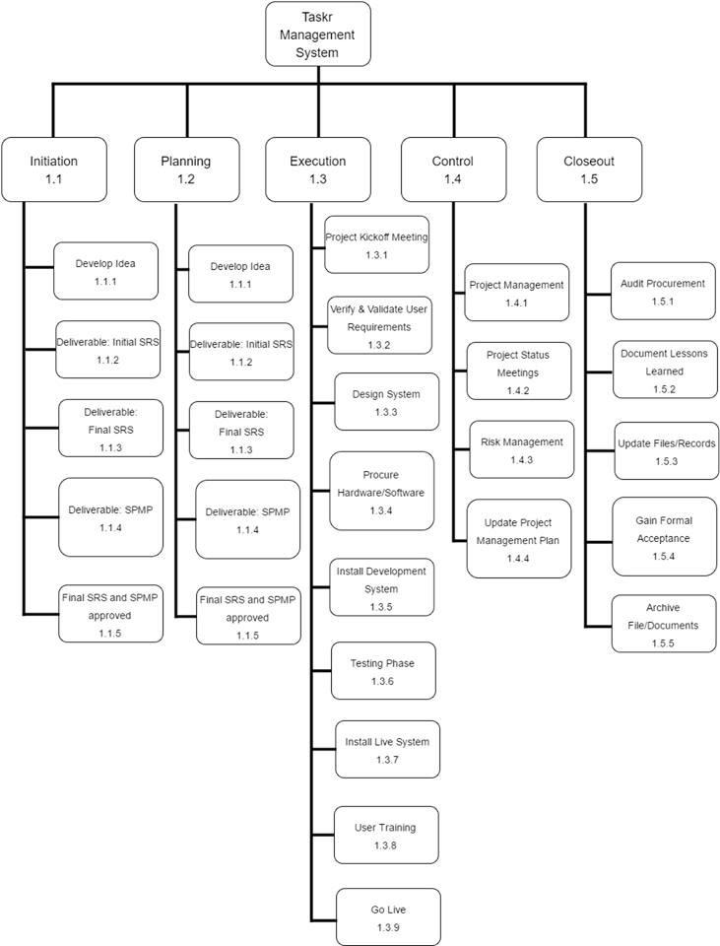

**10.5.2.2   Schedule Allocation Table (Gantt Chart)**

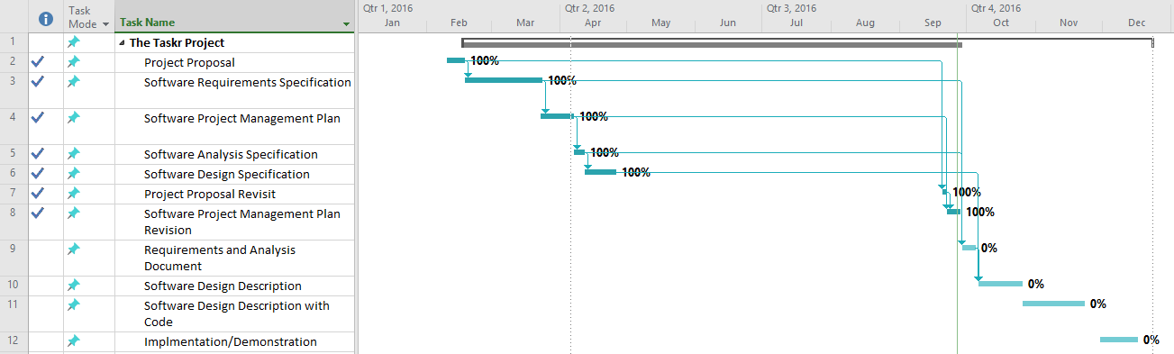

**10.5.2.3   Resource Allocation Table**

|  |  |
| --- | --- |
| **Task Name** | **Work** |
| **Project Proposal**  Project Manager  Technical Writers | **10 hours**  3 hours  8 hours |
| **SRS - Initial**  Project Manager  Technical Writers  Requirements Analyst | **40 hours**  10 hours  20 hours  10 hours |
| **SRS - Final**  Project Manager  Technical Writers  Requirements Analyst | **30 hours**  7 hours  15 hours  8 hours |
| **SPMP - Initial**  Project Manager  Technical Writers  Requirements Analyst  Software Designer | **60 hours**  15 hours  20 hours  10 hours  15 hours |
| **SAS**  Project Manager  Technical Writers  Requirements Analyst | **40 hours**  10 hours  20 hours  10 hours |
| **SPMP - Final**  Project Manager  Technical Writers  Requirements Analyst  Software Designer | **15 hours**  5 hours  5 hours  3 hours  2 hours |
| **RAS**  Project Manager  Technical Writers  Requirements Analyst | **50 hours**  20 hours  20 hours  10 hours |
| **SDD**  Project Manager  Technical Writers  Software Designer | **50 hours**  20 hours  20 hours  10 hours |
| **Implementation**  Project Manager  Programmers  Training Specialist | **35 hours**  5 hours  20 hours  5 hours |

**10.6.1** 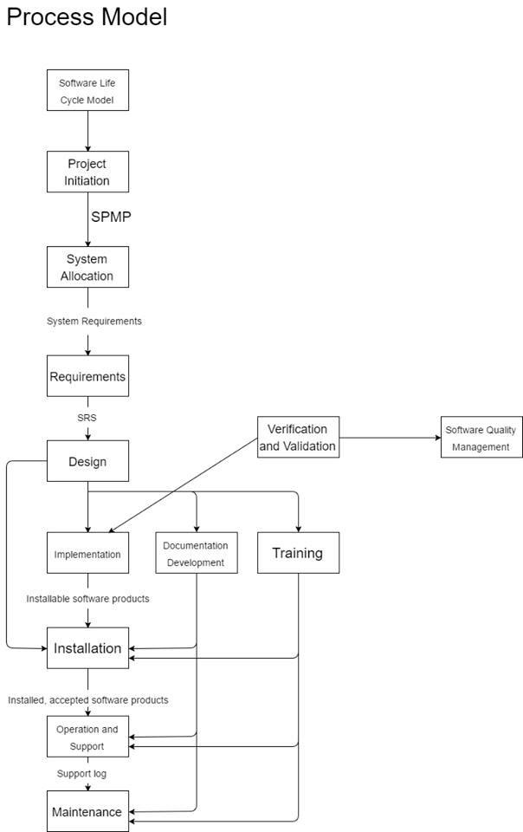

**10.7.3   Documentation (Library) Plan**

|  |  |  |  |  |  |
| --- | --- | --- | --- | --- | --- |
| Document | Preparer | Reviewer | Approver | Baseline Version | Distribution List |
| SRS | Developers | Developers, SQA group | Developers, SQA group | 1.0 | Repository, Reviewer, Preparer, Advisor |
| SPMP | Developers | Developers, SQA group | Developers, SQA group | 1.0 | Repository, Reviewer, Preparer, Advisor |
| SDD | Developers | Developers, SQA group | Developers,  SQA group | 1.0 | Repository, Reviewer, Preparer, Advisor |
| SAS | Developers | Developers, SQA group | Developers, SQA group | 1.0 | Repository, Reviewer, Preparer, Advisor |
| Architectural Descriptions | Developers | Developers | Developers | N/A | Repository, Reviewer, Preparer |
| Traceability Metrics | Developers | Developers | Developers | N/A | Repository, Reviewer, Preparer |
| Test Plans | Developers | Developers, SQA group | Developers, SQA group | 1.0 | Repository, Reviewer, Preparer, Advisor |
| Meeting Minutes | Developers | Participants | N/A | N/A | Repository, Reviewer |
| Review Reports | SQA group | Participants | SQA group | N/A | Repository, Reviewer |

**10.7.5   Reviews and Audits Plan**

|  |  |  |  |  |
| --- | --- | --- | --- | --- |
| Review | Schedule | Resources | Methods | Procedures |
| Management Reviews | Monthly | Developers, SQA group, advisor | Review schedule and budget. | 1. A meeting is held with all participants.  2. A meeting agenda is distributed.  3. Agenda items are reviewed, and if necessary, a resolution plan is created to ensure the schedule and budget are followed. |
| Developer Peer Reviews | Weekly | Developers | Review documents being worked on.  Find defects.  Schedule fixes. | 1. Each participant will individually review the document, tallying any defects found. 2. All defects will be pooled together.  3. Minor defects will be fixed  4. A meeting will be held for large defects in order to create a plan to fix them.  5. Distribute review summary to each participant. |
| Technical Reviews | Weekly | Developers,  SQA group | Find and fix defects. | 1. Each participant will work on a shared document.  2. When a defect is found, other participants are notified, and this defect is documented.  3. Once all found defects are documented, they can be handled based on their priority. |
| Walkthroughs | Bi-weekly | SQA group | Find defects. | 1. The material should be distributed to participants in advance.  2. Participants should make a list of things they do not understand, and a list of things they believe are incorrect.  3. Each fault or incorrect item is addressed. Misunderstandings can be cleared up. Faults are confirmed to be faults.  4. Each fault is then documented. |
| Inspections | Bi-weekly | SQA group | Find defects. | 1. An overview document is inspected by all participants. Then, the full document is given to all participants.  2. Participants understand the document in detail.  3. One participant walks through the document, ensuring all items are covered.  4. Within 1 day, the inspection leader must produce a report of the inspection.  5. The document author(s) resolve all faults in the inspection report.  6. The inspection moderator ensures all faults have been resolved correctly. |
| Audits | Weekly | SQA group | Evaluate audits. Accept or decline it. | 1. Identify item to be audited. An audit report is made.  2. Analyze the report and evaluate the audit.  3. Determine whether or not to accept or decline the audit. |